UML Diagrams for HOSPITAL MANAGEMENT SYSTEM

Use case Diagram 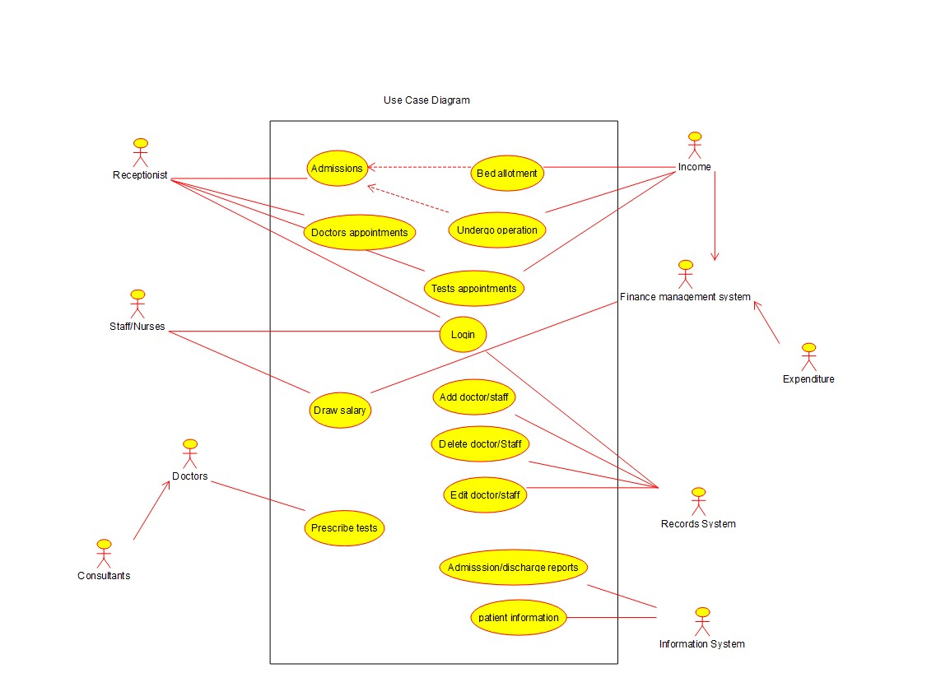

Deployment Diagram

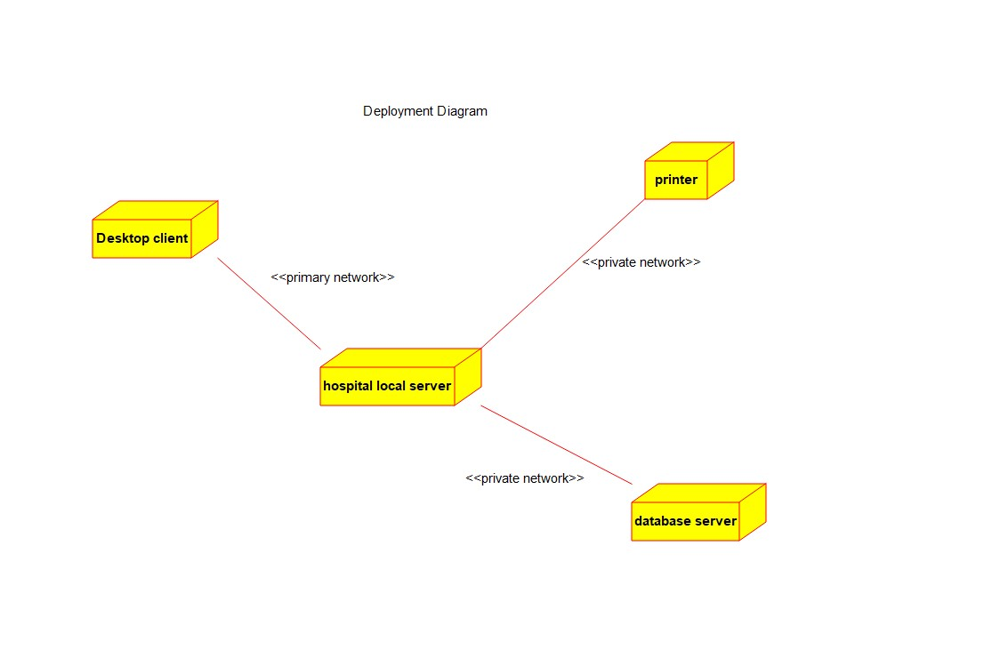

Activity Diagram

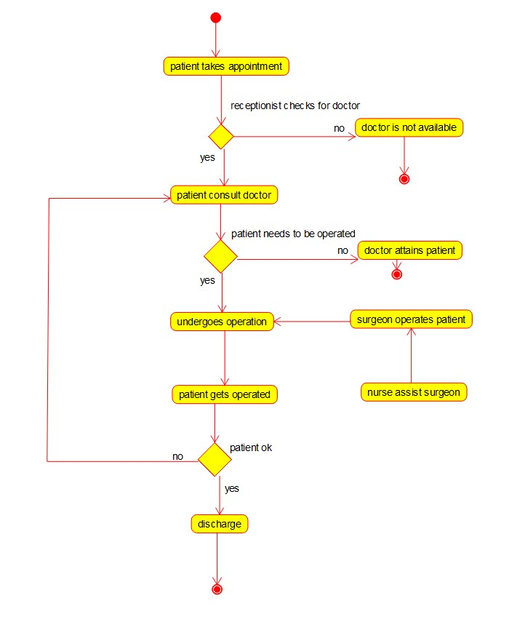

State Chart Diagram

